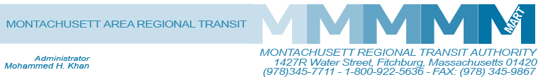

Posted 10/23/2015 at 8:23 am by JAV

MEETING OF THE MART ADVISORY BOARD
MART Maintenance Facility
1427R Water Street
Fitchburg, MA 01420

Thursday, October 29, 2015
10:30 A.M.

Agenda

- Call to Order

- General Comments

- Approval of August 11, 2015 minutes
RESOLUTION - BE IT RESOLVED that the Advisory Board of the Montachusett Regional Transit Authority approves the August 11, 2015 minutes as presented.

- Financial Matters
- Status of State Funding
- Status of Federal Funding
- Finance Committee Report
- Audit FY2015-Presentation by Stowe & Degon
- Audit Sub-Committee Report
- Acceptance of Audit as Presented
- Executive Compensation Sub-Committee Report
- Outlook for 2016 for MART Operation and Financial Status

V. Administrative Matters
- Possible Cost of Living Adjustment for Existing Staff During 2016
- CFO to Explore Various Pension Options for MART Staff

VI. Other Business

VII. Adjournment

